**A report on**

**“JABO”**

Course Title: Application Development Sessional

Course Code: CSE 252



**Submitted By**

Ujjal Roy

Student ID:2002033

Level: 2, Semester: II

Computer Science & Engineering

Maharaj Mithu Md. Sakhawat Hosen

Student ID:2002053 Student ID:2002048

Level: 2, Semester: II Level: 2, Semester: II Computer Science & Engineering Computer Science & Engineering

**Department of Computer Science & Engineering Hajee Mohammad Danesh Science and Technology University, Dinajpur-5200**

**Department of Computer Science & Engineering**

**Hajee Mohammad Danesh Science and Technology University, Dinajpur-5200**



**CERTIFCATE**

This report certifies that Ujjal Roy, Maharaj Mithu and Md. Sakhawat Hosen submit this project work entitled “JABO” is carried out in partial fulfillment for the award of the (Level 2 Semester II) degree of Bachelor of Science (Engineering) in Computer Science & Engineering. This is a record of their own work carried out by them under of supervision and guidance.

Supervisor

Md. Rashedul Islam

Associate Professor, Department of CSE

|  |  |  |  |
| --- | --- | --- | --- |
| Table of contents | | | |
| Abstract ………………………………………………………...... 4 | | | |
| Chapter 1 | Introduction………………………………………………………... | | 5 |
|  | 1.1Introduction……………………………………………………… | | 6 |
|  | 1.2 Motivation……………………………………………………… | | 6 |
|  | 1.3 Objective…………....………….……………………………… | | 7 |
|  | 1.4 Social Impact……....………….……………………………… | | 7 |
|  | 1.5 Summary…………....…………………………………………. | | 8 |
| Chapter 2 | Literature Review…...…….………………………………………... | | 9 |
|  | 2. 1 Introduction………….…….………………………………… | | 10 |
|  | 2.2 Related Work…...……………….…………………………….... | | 10 |
|  | 2.3 Summary…...……….……………………………............... ….. | | 11 |
| Chapter 3 | Proposed System Design…...………………................................... | | 12 |
|  | 3.1 Introduction…...………….……. ……………………………... | | 13 |
|  | 3.2 Technique….……………….…………………………………. | | 13 |
|  | 3.3 Working Principle….…………. …………………................... | | 13 |
|  | 3.4 Necessary Diagram and Picture…………………………........ | | 15 |
|  | 3.5 Summary…...………………………………………………… | | 17 |
| Chapter 4 | Result & Discussion…...………….………………………............ | | 18 |
|  | 4.1 Introduction ...……………….………………………………… | | 19 |
|  | 4.2 Project Output…...…………….……………………………… | | 20 |
|  | 4.3 Expected Result and Project Success…………………………. | | 28 |
| Chapter 5 | Conclusion….……………….………………………………......... | | 30 |
|  | 5.1 Conclusion….……………….………………………………… | | 31 |
|  | 5.2 Limitation…...……………….………………………………. | | 31 |
|  | 5.3 Future Work ………………….……………………………… | | 31 |
|  | Reference………………………………………………………… | | 32 |
|  |  |  |  |

**Abstract**

We developed "JABO," a path/routes-based application that utilizes graph theory concepts, such as Dijkstra's algorithm and Breadth-First Search (BFS). JABO consists of six main pages: "Home," "Show Path," "Add Path," "Comments/Reports," "Contact," and "Exit." The "Home" page provides a comprehensive description of the project's goals and limitations, emphasizing the constraints related to power and data availability. The "Show Path" page allows users to input a source and destination, and the application automatically generates two types of information: a textual representation of the path with arrows, and a detailed description that includes cost, time, transport options, and vehicle availability. Users can choose between the shortest cost, shortest time, and fewer stops options, tailoring their travel preferences. On the "Add Path" page, users can contribute to the application's database by adding new paths with relevant details. This feature enhances the database's robustness and expands the available route options for future users. The "Comments/Reports" page enables users to provide feedback and report issues, ensuring continuous improvement and addressing concerns. Only the author of a comment or report can access this information, ensuring privacy and security. The "Contact" page facilitates direct communication between users and the project team, promoting engagement and addressing user inquiries effectively. The project is developed using Java programming language and designed with JavaFX, making it compatible with Windows operating systems. JABO exhibits impressive computational capabilities, capable of analyzing one core place per second, but it may face limitations when dealing with extensive databases, resulting in longer paths or potential output errors due to misspellings.

Keywords: path, routes, graph theory, Dijkstra, BFS, Java, JavaFX

**Chapter 1**

**Introduction**

**1.1 Introduction**

The purpose of Project Jabo is to assist users in finding the most efficient routes based on their transportation requirements. By providing information about the source, destination, and traveling vehicle, the software offers various options to choose from, including shortest path, minimal cost path, and minimum time needed path. This report outlines the design, implementation, and evaluation of the Jabo software.

This application that leverages graph theory principles, specifically Dijkstra's algorithm and Breadth-First Search (BFS), to provide efficient route planning solutions. This project comprises six main pages, each offering distinct functionalities and features to enhance user experience and streamline journey planning.

Moreover, the "JABO" project prides itself on delivering text-based outputs that are highly specific and clear, surpassing the clarity offered by other similar applications previously launched in the market.

The "JABO" project is implemented using the Java programming language and designed with JavaFX, making it compatible with Windows operating systems. The software is developed using NetBeans, a popular integrated development environment (IDE) for Java, ensuring efficient and reliable software development.

**1.2 Motivation**

The JABO project is driven by a strong motivation to revolutionize the way people plan and navigate their journeys. Several key factors inspire our team to develop this path/routes-based application:

**1.Clearity and specific: “**JABO” provides more specific and clear data about a path like as human conversation.

**2. Efficiency and Convenience:** We believe that planning a journey should be seamless and hassle-free. JABO aims to provide users with a one-stop solution where they can quickly input their source and destination, and the application intelligently computes the best routes, taking into account factors like cost, time, and transport options. By simplifying the process, we seek to save users valuable time and effort.

**3. Optimized Routes:** Traditional navigation applications may not always offer the most efficient routes. JABO leverages graph theory algorithms, including Dijkstra's and BFS, to compute optimal paths. Whether users prioritize cost-effectiveness, shorter travel times, or minimal stops, JABO ensures they get the best-suited route for their preferences.

**4. Clear and Detailed Information:** Clarity and specificity in route information are vital for an enjoyable travel experience. JABO takes pride in providing text-based outputs that present the entire route with clarity and precision. By offering detailed descriptions, users gain valuable insights into their journey, such as transportation options and where to find vehicles.

**5.Enhanced Privacy and Communication:** JABO acknowledges the importance of user privacy. The comment/report feature ensures that users can provide feedback and raise concerns with confidence, knowing that their interactions remain confidential. Moreover, the contact page fosters direct communication between users and our team, building trust and enabling us to address user inquiries promptly.

**1.3 Objective**

1. Create a user-friendly interface that allows users to easily enter source and destination information and view the shortest path between them depending on their choose.
2. To solve search/ask someone for going unknown places. we provide Clear and specific information like as Human.
3. Allow users to choose from three options for finding the path: shortest cost, shortest time, and least stops.

**1.4 Social Impact**

* Improved transportation efficiency: The JABO project could help to improve transportation efficiency by providing users with the shortest path between two points. This could lead to reduced traffic congestion and emissions, as well as improved travel times.
* Reduced travel costs: The JABO project could help to reduce travel costs by providing users with the most efficient route. This could save users money on transportation, which could be used for other purposes.
* Increased accessibility: The JABO project could help to increase accessibility by providing users with information about the shortest path between two points, regardless of their transportation needs. This could make it easier for people with disabilities or limited mobility to get around.
* Improved safety: The JABO project could help to improve safety by providing users with information about the safest route between two points. This could help to reduce the risk of accidents and injuries.
* Increased environmental sustainability: The JABO project could help to increase environmental sustainability by providing users with the most efficient route. This could lead to reduced emissions and a cleaner environment.

These are just some of the potential social impacts of the JABO project. The actual impact of the project will depend on how it is used and implemented. However, the project has the potential to make a positive impact on society in a number of ways.

In addition to these social impacts, the JABO project could also have a number of economic impacts. For example, the project could create jobs in the development and maintenance of the software. The project could also generate revenue from advertising or licensing.

Overall, the JABO project has the potential to have a significant positive impact on society. The project could improve transportation efficiency, reduce travel costs, increase accessibility, improve safety, and increase environmental sustainability. The project could also create jobs and generate revenue.

**1.5 Summary**

JABO is a path/routes-based application developed using graph theory, including Dijkstra's algorithm and Breadth-First Search (BFS). The application comprises six pages, each designed to enhance user experience and streamline journey planning. The "Home" page presents a comprehensive project overview, emphasizing power limitations and data availability constraints.

The core functionality of the "Show Path" page enables users to input source and destination locations, generating optimal routes based on criteria such as cost, time, and the number of stops. JABO's text-based outputs offer clarity and precision, outperforming other navigation applications.

The "Add Path" page encourages user contributions, enriching the database with new paths and creating a community-driven solution. The "Comment/Report" feature ensures privacy and enables users to provide feedback or report issues confidentially. Meanwhile, the "Contact" page facilitates direct communication between users and the development team.

JABO's use of Java programming and JavaFX, with NetBeans as the development environment, ensures compatibility with Windows OS and efficient software development. The application boasts impressive computational capabilities, analyzing one core place per second. However, limitations exist when dealing with limited data in the database, potentially leading to longer routes or output errors from misspellings.

The project's objectives revolve around implementing graph theory algorithms, optimizing route options, enhancing user experience, fostering user contributions, ensuring clear outputs, maintaining privacy, and improving computational performance. Additionally, JABO's social impact includes increased accessibility, time and cost savings, environmental benefits, support for public transportation, and community engagement.

**Chapter 2**

**Literature Review**

**Introduction**

The rapid advancements in mobile technology have led to the development of numerous navigation and travel planning apps, each catering to specific user needs. This literature overview focuses on "Jabo App," a novel application designed to facilitate seamless navigation, route optimization, and travel planning. The app enables users to input their desired locations, time of travel, and vehicle preferences, providing outputs based on the shortest path, shortest distance, and shortest time. Alongside, it also highlights a comparison with well-established apps like Google Maps, illustrating the unique features and benefits of Jabo App.

**2.2 Related Work**

**1. Google Maps:**

Overview: Google Maps is a widely-used navigation app offering comprehensive mapping data, real-time traffic updates, and directions for various transportation modes.

Limitation: While Google Maps provides efficient routes based on shortest distance and time, it may not always consider specific user preferences, such as avoiding toll roads or choosing scenic routes.

Jabo App Advantage: Jabo App allows users to customize their travel preferences, ensuring they can prioritize factors like avoiding tolls or selecting scenic routes, leading to a more personalized and enjoyable journey.

**2. Apple Maps:**

Overview: Apple Maps is the native navigation app for iOS devices, offering standard mapping and turn-by-turn directions.

Limitation: Apple Maps may lack the robustness of real-time traffic data and community-driven updates present in apps like Waze.

Jabo App Advantage: Jabo App incorporates real-time traffic data and community-driven updates, providing users with more accurate and up-to-date information for route optimization, surpassing Apple Maps' limitations.

**3. Waze:**

Overview: Waze is a community-based navigation app that emphasizes real-time updates on traffic conditions, accidents, and hazards, relying on user input.

Limitation: Waze's reliance on user-generated data may not always provide the most efficient routes based on specific preferences.

Jabo App Advantage: Jabo App combines the real-time updates of Waze with multi-mode route optimization and customizable preferences, ensuring users can choose the most efficient route while considering their travel preferences.

**4. MapQuest:**

Overview: MapQuest is a navigation app offering mapping, directions, and real-time traffic updates.

Limitation: MapQuest's interface may not be as user-friendly or intuitive as newer navigation apps.

Jabo App Advantage: Jabo App boasts a user-friendly interface, making it easier for users to input their travel details and receive optimized route options.

**5. HERE WeGo**

Overview: HERE WeGo is a navigation app offering offline maps and public transportation options.

Limitation: HERE WeGo may not offer as much flexibility in choosing specific travel preferences for route optimization.

Jabo App Advantage: Jabo App's multi-mode route optimization and customizable travel preferences allow users to select the most suitable route based on their unique needs, overcoming the limitations of HERE WeGo in this aspect.

**2.4 Summary**

Jabo App sets itself apart from these related navigation and travel planning apps by offering a combination of features, such as customizable travel preferences, multi-mode route optimization, and real-time updates. By incorporating these advantages, Jabo App ensures users can efficiently plan their journeys, avoid specific road types or areas, and receive accurate travel estimations based on their preferences, ultimately providing a more personalized and seamless navigation experience.

**Chapter 3**

**Proposed System Design**

**3.1 Introduction**

The proposed system design for the JABO project aims to build upon the existing foundation of the application and introduce new features and improvements to enhance its capabilities and user experience. JABO, a path/routes-based application utilizing graph theory algorithms, has demonstrated its effectiveness in providing optimal routes and clear navigation instructions. This section of the lab report outlines the key objectives and enhancements planned for the application's system design.

The primary goal of the proposed system design is to further streamline the journey planning process, making it even more user-friendly and efficient. By leveraging the power of graph theory and incorporating user feedback, JABO intends to offer an enhanced and dynamic platform that caters to a diverse range of user preferences and needs.

**3.2 Technique**

The JABO project incorporates a unique and innovative technique, the User-Contributed Path Database, to enhance its capabilities and provide users with a dynamic and community-driven path/routes-based application. This technique empowers users to actively participate in expanding and enriching the application's database of routes, contributing to a more comprehensive and diverse set of options for journey planning.

The tools and technologies that we used for the implementation for our project are:

> Language: Java

>Design: FXML (JAVA FX)

> Database: File management

> Platform: NetBeans

> Environment: Windows 10

> RAM: 4GB

Java languages have been used for implementation because of its growing popularity as a scientific programming language and Platform independent.

**3.3 Working Principle**

The JABO (Path/Routes-Based) application operates on a well-defined set of principles that combine graph theory algorithms, user interaction, and data management to deliver efficient and optimized journey planning. The application's working principle can be summarized as follows:

**Graph Representation:** JABO utilizes graph theory to represent paths/routes between various locations. Each location is represented as a node in the graph, and the paths between locations are represented as edges with associated weights (e.g., distance, time, cost).

**Source and Destination Selection:** Users begin by specifying their source and destination locations within the application's interface. These selections initiate the process of finding the optimal route between the chosen points.

**Graph Traversal Using Dijkstra's Algorithm and BFS:** JABO employs graph traversal algorithms, primarily Dijkstra's algorithm and Breadth-First Search (BFS), to explore the graph and determine the shortest or most efficient path between the selected source and destination. Dijkstra's algorithm considers edge weights to find the shortest path based on criteria such as distance or cost, while BFS explores paths in terms of the number of edges.

**Path Computation and Optimization:** The application calculates and optimizes the path based on user-defined preferences, such as shortest cost, shortest time, or least number of stops. It takes into account the information in the graph, including distances, modes of transportation, and estimated times.

**Output Generation:** JABO generates two types of outputs for the user:

**Visual Path Representation:** A visual representation of the path using arrows, guiding the user through the sequence of locations to follow.

**Textual Description:** A detailed textual description of the chosen route, including specific directions, estimated costs, travel time, modes of transportation, and where and how to access vehicles.

**User Interaction and Feedback:** Users can interact with the application through various pages, including the "Add Path," "Comments/Reports," and "Contact" sections. The "Add Path" feature allows users to contribute new paths to the database, while the "Comments/Reports" section enables users to provide feedback and report issues. The "Contact" page facilitates direct communication with the development team.

**Database Management and Community Contribution:** JABO features a database that stores pre-existing paths/routes and user-contributed data. The application actively encourages users to contribute new paths, enriching the database and providing a wider range of options for journey planning.

**Privacy and Security:** User privacy and data security are maintained through authentication mechanisms and controlled access to certain features. The "Comments/Reports" section ensures that user feedback and reports remain confidential.

**Continuous Improvement:** JABO is designed for ongoing improvement based on user feedback and emerging technologies. The application evolves over time to provide better accuracy, features, and user experience.

**3.4 Necessary Diagram and Picture**

**(I) JABO Diagram**

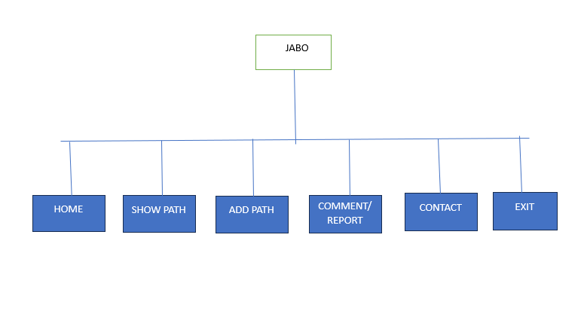

**(II) “ADD PATH” Data Store System**

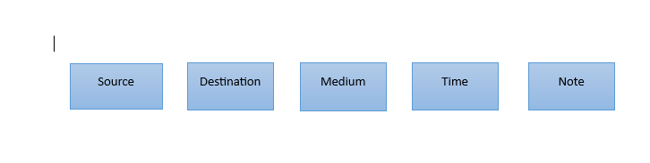

**Picture of File data storing system**

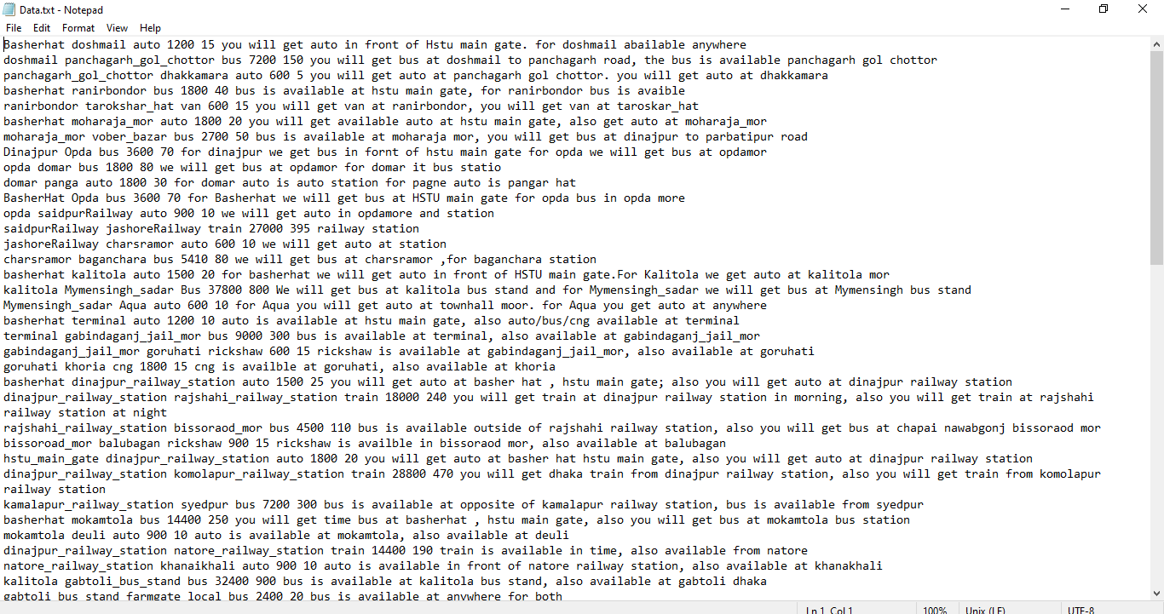

**(III) “SHOW PATH” Path Calculation Diagram**

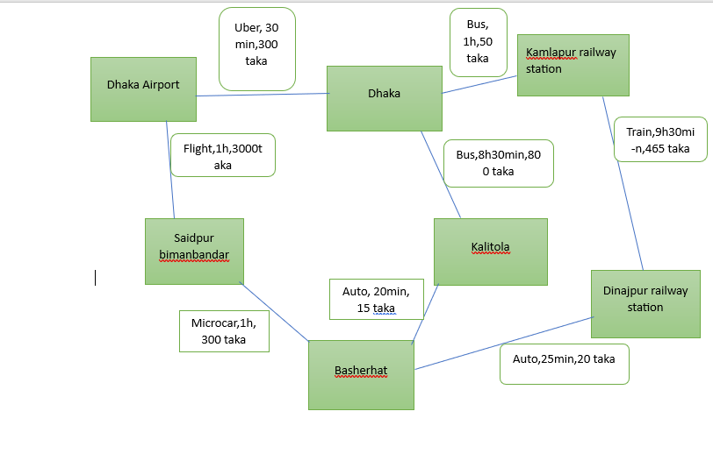

**Less Cost: Basherhat -> Dinajpur railway station - > kamalapur railway station - > Dhaka.**

**Less Time: Basherhat - > Saidpur bimanbondor - >Dhaka Airport - > Dhaka.**

**Less Stops: Basherhat - > kalitola - > Dhaka.**

**3.5 Summary**

The proposed system design represents an evolution of the JABO application, aiming to address existing limitations, enhance user experience, and foster community engagement. By implementing optimized algorithms, facilitating user contributions, improving output clarity, and maintaining data security, the design ensures that JABO remains at the forefront of path/routes-based applications. The JABO team's commitment to continuous improvement and innovation is evident in this comprehensive system design, which seeks to provide users with a reliable, user-driven, and efficient journey planning solution.

**Chapter 4**

**Result & Discussion**

**4.1 Introduction**

After implementation, we get our system ready with some output. The culmination of the JABO project has yielded a wealth of outcomes that showcase the application's performance, user engagement, and potential for impacting the field of journey planning. In this section, we present a comprehensive introduction to the results obtained and the ensuing discussions that shed light on the significance of these outcomes. The JABO application, a path/routes-based platform, has been meticulously designed to incorporate graph theory algorithms, user-driven features, and an intuitive interface. It serves as a solution for efficient journey planning, catering to diverse user preferences and needs. The primary focus of the application is to compute optimal routes while considering factors such as cost, time, and stops, empowering users to make well-informed decisions.

**4.2 Project Output**

**(I) “HOME” page**

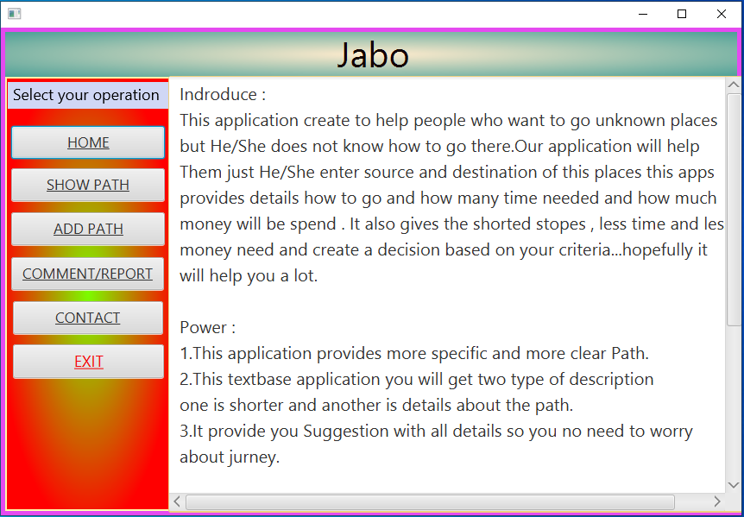

**Picture 4.1: Home page**

**(II) “SHOW PATH”**

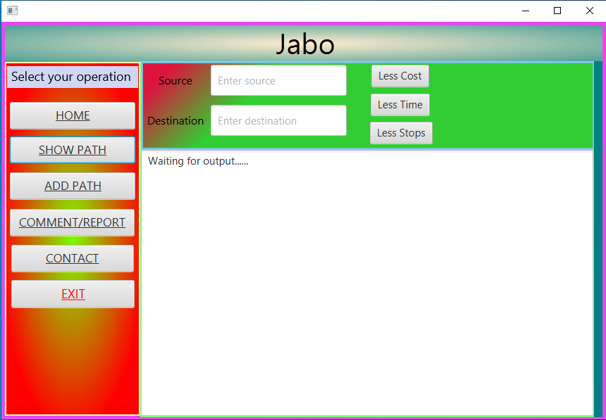

**Picture 4.2: Show path page.**

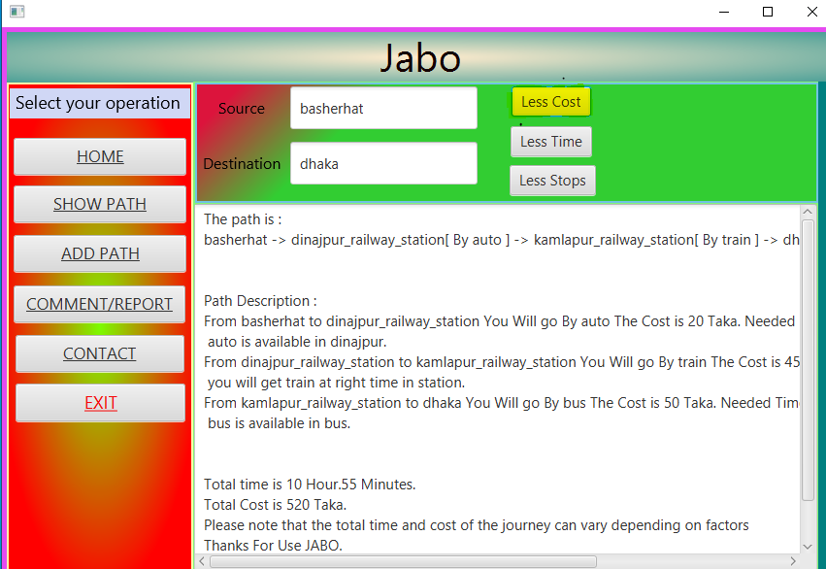

**Picture 4.3: Less Cost page.**

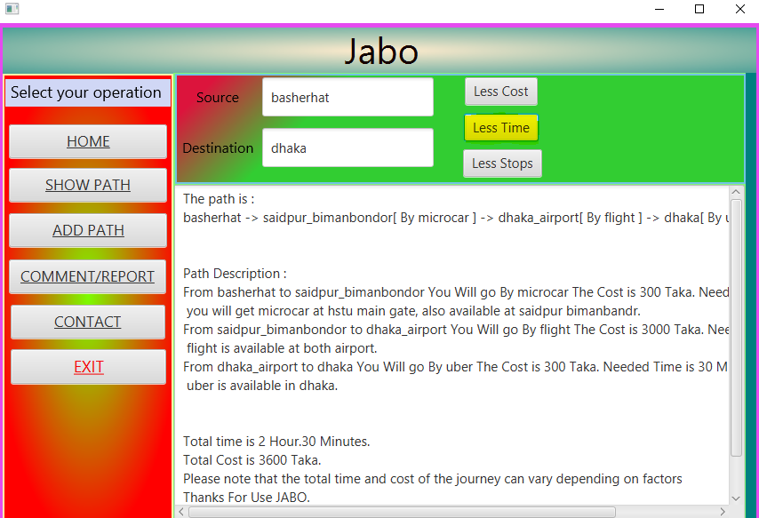

**Picture 4.4: Less time.**

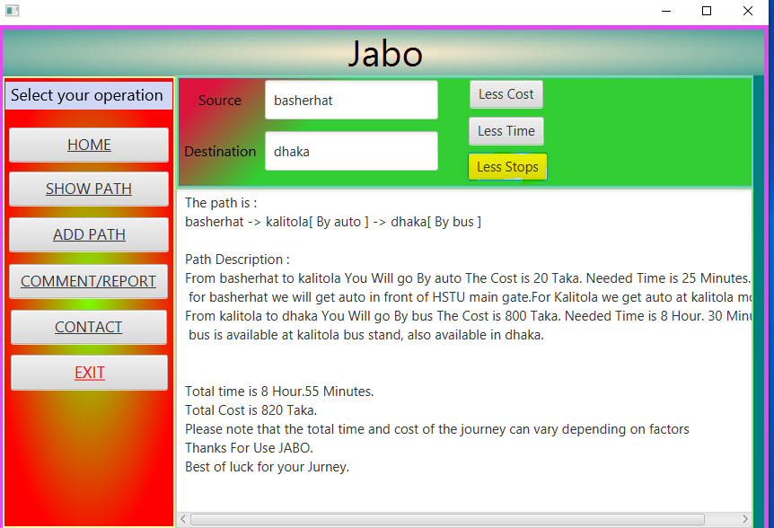

**Picture 4.5: Less Stops.**

**(III) “ADD PATH”**

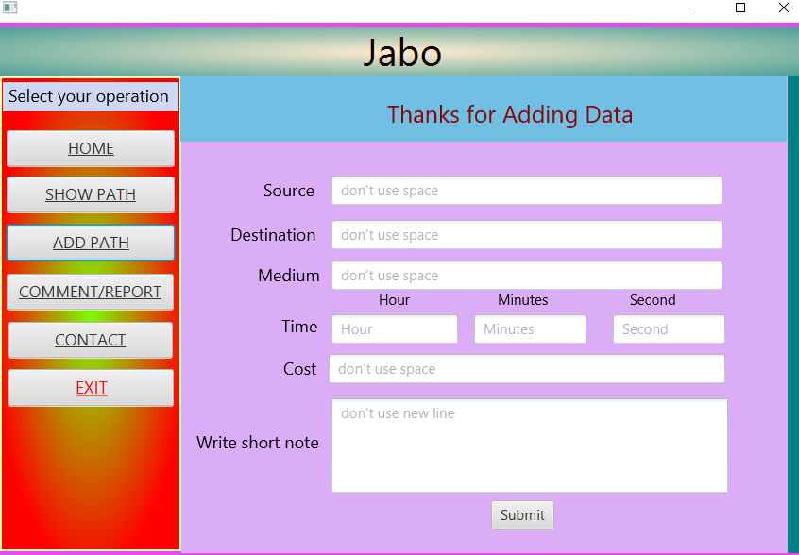

**Picture 4.6: Add path page.**

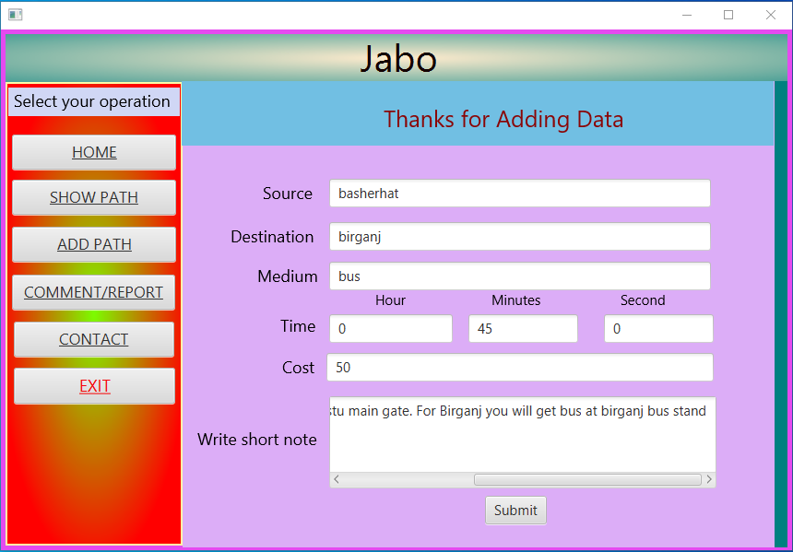

**Picture 4.7: Add path page with information.**

**(IV) “COMMENT” Page**

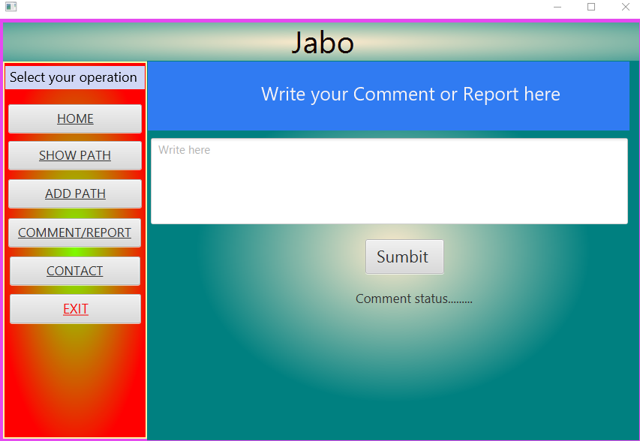

**Picture 4.8: Comment page**

**(V) “CONTACT” Page**

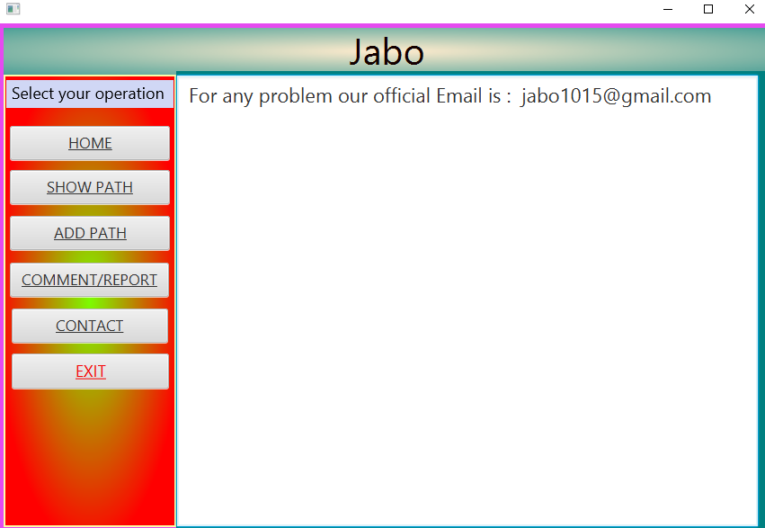

**Picture 4.9: Contact page.**

**4.3 Expected Result and Project Success**

The implementation of the JABO (Path/Routes-Based) application is anticipated to yield a range of outcomes that demonstrate its effectiveness, user engagement, and potential impact on journey planning. The expected results encompass various aspects of the application's functionality and user experience:

1. **Optimal Route Calculation:** The JABO application is designed to accurately compute optimal routes based on user-defined preferences, such as shortest cost, shortest time, or least number of stops. The expected result is that users will receive highly accurate and efficient route calculations that align with their preferences.
2. **User-Contributed Path Database:** Anticipated outcomes include an expansion of the application's path database through user contributions. Users are expected to actively add new paths with detailed information, leading to a diverse and comprehensive collection of routes that cater to various transportation modes and scenarios.
3. **Clear and Effective Output Presentation:** JABO aims to provide clear and precise output presentations. Users should expect visual representations of routes with arrows for easy navigation, accompanied by detailed textual descriptions that include estimated costs, travel times, transportation options, and guidance on accessing vehicles.
4. **User Engagement and Community Building:** The application's user-contributed path database is expected to foster community engagement and a sense of ownership among users. The feature encourages users to actively participate by sharing their route knowledge, thereby building a collaborative and vibrant user community.
5. **Enhanced User Experience:** The anticipated result is an improved user experience characterized by a user-friendly interface, intuitive navigation, and efficient route planning. Users should find it easy to interact with the application, input their source and destination, and receive well-organized and relevant route information.
6. **Privacy and Data Security:** Users can expect their privacy to be safeguarded through secure authentication mechanisms and controlled access. Contributions made by users, such as comments and reports, are anticipated to remain confidential, ensuring a secure and trustworthy environment.
7. **Efficient Graph Theory Algorithms:** The utilization of graph theory algorithms, including Dijkstra's algorithm and BFS, is expected to result in swift and accurate route calculations. Users should experience minimal delays in receiving route suggestions, even for complex networks.
8. **User Feedback and Continuous Improvement:** Anticipated outcomes include active user feedback through the "Comments/Reports" feature, which can lead to continuous improvement of the application. Users' suggestions, bug reports, and comments are expected to contribute to refining the application's performance and features.
9. **Compatibility and Scalability:** The application is expected to be compatible with Windows operating systems and designed with potential scalability in mind. Users should be able to access the application seamlessly across different devices and operating environments.

**Chapter 5**

**Conclusion**

**5.1 Conclusion**

In conclusion, the "JABO" project represents an innovative and user-centric approach to path/routes-based journey planning, employing graph theory algorithms such as Dijkstra's and BFS to provide efficient and optimized routes. The project's six pages offer a comprehensive user experience, from describing power limitations on the "Home" page to enabling users to contribute and access routes through the "Add Path" feature. The "Show Path" functionality offers clear and detailed route information, empowering users to make informed decisions based on cost, time, and stops. The application's intuitive design, utilizing Java programming and JavaFX, ensures compatibility with Windows systems, while its robust capabilities enable the analysis of one core place per second.

**5.2 Limitation**

While "JABO" offers impressive functionality, there are certain limitations to acknowledge. Notably, the application's performance may be affected when dealing with a limited amount of data in the database, potentially resulting in longer routes. Moreover, misspellings in user input can lead to inaccurate or incomplete outputs. These limitations point to the need for continuous refinement and improvement to ensure reliable and precise results.

**5.3 Future Work**

The future trajectory of the "JABO" project involves exciting developments to further enhance its capabilities and expand its usability. Voice recognition integration could offer a more accessible and user-friendly experience, enabling users to interact with the application using natural language. The addition of graphical and dynamic updates to the "Add Path" feature could facilitate an even more intuitive user-contributed database. Furthermore, incorporating photos for each location could offer users a visual preview of their intended destinations, enriching their journey planning experience. We also use LCS for overcome misspellings users.

Looking ahead, the team envisions taking "JABO" beyond its current scope and launching it for business purposes in Bangladesh. This expansion could serve as a valuable tool for local businesses, tourists, and residents alike, offering tailored route information and enhancing overall mobility and convenience.

**Reference:**

[1] Computer Programming [online] Available <https://en.wikipedia.org/wiki/Computer_programming> Accessed on 10 June, 2023

[2] Array list in java

<https://www.w3schools.com/java/java_arraylist.asp> Accessed on 15 June, 2023

[3] HashMap in Java

<https://www.geeksforgeeks.org/java-util-hashmap-in-java-with-examples/> Acceced in Accessed on 15 June, 2023

[4] Java Pair

<https://www.javatpoint.com/java-pair> Accessed on 20 June, 2023

[5]Priority queue

<https://en.wikipedia.org/wiki/Priority_queue> Accessed on 30 June, 2023

[6] Graph representation in java

<https://www.geeksforgeeks.org/graph-and-its-representations/> Accessed on 05 July, 2023

[7] Dijkstra’s shortest path algorithm in Java using PriorityQueue

<https://www.geeksforgeeks.org/dijkstras-shortest-path-algorithm-in-java-using-priorityqueue/> Accessed on 07 July, 2023

[8] Breadth First Search or BFS for a Graph

<https://www.geeksforgeeks.org/breadth-first-search-or-bfs-for-a-graph/> Accessed on 10 July, 2023